**Idioms used to Describe People**

1. **Party animal** – someone who likes to attend parties often.
2. **Cold fish** – someone who shows very little emotion, who is regarded as hard-hearted and unfeeling.
3. **Lone wolf** – someone who prefers his own company and does not like socializing.
4. **Smart cookie** – somebody who is quite smart.
5. **Chatterbox** – a person who talks a lot.
6. **Good egg** – a good egg is a good person.
7. 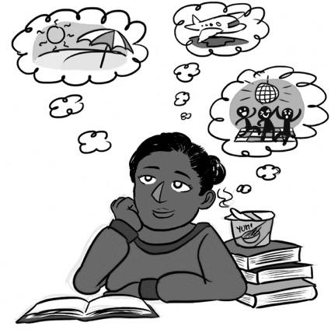**Early bird** – a person who wakes up, arrives to work, etc. before the usual time. This expression comes from the English proverb “The early bird catches the worm”.
8. **Busybody** – a person who expresses great interest in other people’s private lives.
9. **Daydreamer** – someone who is having dreamlike thoughts when they should be focusing on the present.
10. **Down-to-earth** – practical, reasonable, and friendly.

**Fill in the blanks with the correct idiom:**

1. My next-door neighbor is a real ________________________. He watches people from his window.
2. My mother is the ___________________________ in our family, she gets up at 5 o’clock in the morning.
3. Mary was the type of person who would have helped anyone – a real __________________________.
4. Carol is such a __________________________. She never stops talking!
5. Are you going out again tonight? You are such a ____________________________.
6. Jack became a real ______________________________ since his wife passed away last year. He never goes out.
7. Joe said nothing at all when I told him about my problems. He is a ______________________.
8. Emilie is such a ______________________________________, she can make any project a success.
9. She is a very ______________________________________ person, not at all attracted by clothes, fancy things, and glamor.
10. George is a _________________________________. He likes to imagine his dream vacation while he sits in class.

